Project 4: Finite Element Analysis of a Carport

CEE 532: Developing Software for Engineering Applications

Date: 12-3-15

Authors: Michael Justice, James Meyer

Table of Contents

1.0 Problem Description 4

Fig. 1.0-1: Plan View of Carport Structure 4

Fig 1.0-2: Cross-Section View of Carport 5

1.1 Design Assumptions and Goals 5

1.2 Loads 6

Table 1.2-1: Snow Load Constants for Calculation of Roof Snow Load 6

Table 1.2-2: Wind General Requirements 6

Table 1.2-3: Wind Pressure Types Used for Structural Members 8

2.0 Finite Element Model 9

Fig. 2.0-1: Example Profile View of GSUSA Model 10

2.1 Material Properties 10

Table 2.1-1: Material Properties 10

2.2 Cross-Sectional Properties 11

Table 2.2-1: Element Cross-Sectional Properties 11

3.0 Finite Element Results 11

Fig. 3.0-1: Von Mises Stress Distribution of Model 1 12

Fig. 3.0-2: Von Mises Stress Distribution of Model 2 12

Fig. 3.0-3: Von Mises Stress Distribution of Model 3 13

Fig. 3.0-4: Von Mises Stress Distribution of Model 4 14

Table 3.0-1: Results from the Finite Element Analysis 14

Fig. 3.0-5: Displacement versus # of Plate Elements 15

Fig. 3.0-6: von Mises Stress versus # of Plate Elements 15

3.1 Analysis of Carport with Basic Load Cases 16

Figure 3.1-1: Governing Wind Load Case for CC 16

Figure 3.1-2: Von Mises Stress Distribution for Governing Wind Load Case for CC 17

Figure 3.1-3: Tensile Stress Distribution for Governing Wind Load Case for CC 17

Figure 3.1-4: Compressive Stress Distribution for Governing Wind Load Case for CC 18

Figure 3.1-5: Shear Stress Distribution for Governing Wind Load Case for CC 18

Table 3.1-1: Stresses for Gov. C&C Wind Pressure 19

Figure 3.1-6: Governing Wind Load Case for MWFRS 19

Figure 3.1-7: Tensile Stress Distribution for Governing Wind Load Case for CC 20

Figure 3.1-8: Compressive Stress Distribution for Governing Wind Load Case for CC 20

Figure 3.1-9: Shear Stress Distribution for Governing Wind Load Case for CC 21

Table 3.1-2: Stresses for Gov. MWFRS Wind Pressure 21

Fig. 3.1-10: Live Load 22

Figure 3.1-11: Tensile Stress Distribution for Live Load Case 22

Figure 3.1-12: Compressive Stress Distribution for Live Load Case 23

Figure 3.1-13: Shear Stress Distribution for Live Load Case 23

Table 3.1-3: Stresses for Live Load Case 23

Figure 3.1-14: Tensile Stress Distribution for Snow Load Case 24

Figure 3.1-15: Compressive Stress Distribution for Snow Load Case 25

Figure 3.1-15: Shear Stress Distribution for Snow Load Case 25

Table 3.1-4: Stresses for Live Load Case 25

4.0 Conclusions 26

5.0 References 27

# 1.0 Problem Description

The structure being analyzed is a three-dimensional carport located in San Diego, CA, shown in Fig. 1.0-1 and Fig. 1.0-2 below. It is subjected to environmental loading conditions that include wind and snow loads, as well as a roof live load on the top of the carport and the dead load of the structure. The carport meets the minimum height requirements of 8 feet per typical city standards, and is constructed with four different element cross-sectional properties, along with three different material properties. The different element cross-sections of the structure include doubly-symmetric I sections of different sizes for the columns and beams, a channel section for the purlins, and a corrugated deck for the cover of the carport. The three material properties used in the structure include A992 Grade 50 Hot-Rolled Steel and A446 Cold-Formed Steel (Light-Gauged CFS for Purlins and Corrugated CFS for Decking).

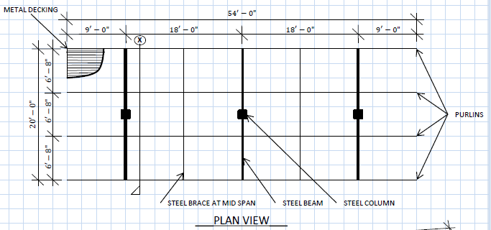

### Fig. 1.0-1: Plan View of Carport Structure

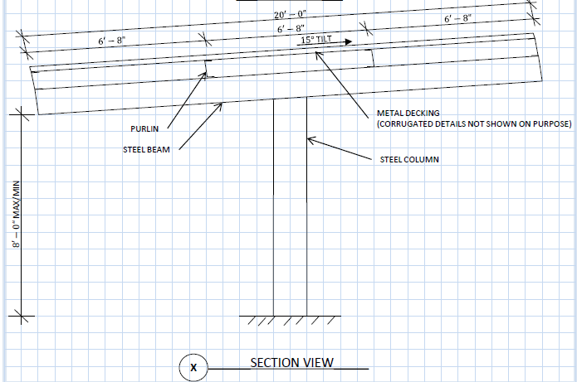

### Fig 1.0-2: Cross-Section View of Carport

## 1.1 Design Assumptions and Goals

Some of the assumptions made in order to model the structure in a finite element analysis program include modeling the corrugated metal decking as thin plate elements, instead of producing irregular plate shapes to model the corrugated nature of the decking. Another assumption made is that all connections are rigid connections, meaning if a connection were to move about in space, the geometric characteristics that are shared between the connected elements would remain the same. Another assumption is that the soil produces such a condition that the columns are completely fixed, allowing no displacement or rotation.

The goals of this modeling project were to determine how the stresses are developed throughout a carport structure under code-based loading, and appropriately size the structural elements to withstand the governing load condition (only basic load cases were used).

## 1.2 Loads

All of the loads used in modeling the structure are in compliance with the 2013 edition of the California Building Code. The basic load cases are as follows:

* Dead Load: Self-Weight of Structure
* Roof Live Load (Lr): 20 psf (ASCE 7-10, Section 4.3.1, Table 4-1)
* Snow Load (S): 5 psf (ASCE 7-10, Ch. 7)
* Wind Loads (W): Risk Category1, Exposure D, 3-Sec Wind Gust = 100 mph (ASCE 7-10, Ch. 27 and 30)

The three main basic load cases, Lr, S and W, were determined using the design procedure outlined in ASCE 7-10. The roof live load was determined by categorizing the roof of the structure as one that has “Ordinary flat, pitched and curved roofs”. As per Table 4-1, the roof live load was taken to be 20 psf. The snow load used in the design was determined from Figure 7-1 of Section 7.2, which details the design ground snow loads across different regions of the United States. For a site in San Diego above 1800 feet in elevation, a ground snow load of 5 psf was used. Note that the ground snow load (pg) was used in the analysis as opposed to the sloped roof snow load (ps). Table1.2-1 below contains the constants used in determining the roof snow load as per equation 7.3-1. All constants below are determined between Tables 1.5-1, 7-2 and 7-3.

#### Table 1.2-1: Snow Load Constants for Calculation of Roof Snow Load

|  |  |  |  |  |
| --- | --- | --- | --- | --- |
|  | **Pg** | **Ce** | **Ct** | **Is** |
| Values: | 5 psf | 0.8 | 1.2 | 0.8 |

Considering that the roof slope factor Cs is 1.0 (Fig. 7-2c), the roof snow load is equivalent to the sloped roof snow load, which equates to 3.84 psf (as per equation 7.4-1). Since the analysis of the structure was performed with a ground snow load of 5 psf, this is proven as conservative.

For the wind loads, the three-second gust for a site in San Diego was determined to be 100 mph as per Figure 26.5-1C (risk category I). The wind directionality factor Kd was determined as per Section 26.6 (“Arched Roofs”, 0.85), the exposure category as per Section 26.7.3 (Exposure D), the topographic factor Kzt as per Section 26.8.1 (1.0, as site is assumed to not be located on or near hills, ridges, or escarpments that meet the conditions outlined in aforementioned section), and Gust Effect Factor as per section 26.9.1 (0.85 for rigid building). Table 1.2-2 below shows the general requirements for wind loading as previously mentioned.

#### Table 1.2-2: Wind General Requirements

|  |  |  |  |  |  |
| --- | --- | --- | --- | --- | --- |
|  | **3-Sec Gust** | **Dir. Fact. Kd** | **Exposure Catg.** | **Topo. Fact. Kzt** | **Gust Eff. Fact.** |
| Values : | 100 mph | 0.85 | D | 1.0 | 0.85 |

Using these general requirements for wind loading, the MWFRS (Main Wind Force Resisting System) and C&C (Components and Cladding) wind pressures can be computed using the directional procedures outlined in chapters 27 and 30, respectively. Below is snippet of the wind charts used to determine the wind pressures for both MWFRS (the beam-column elements) and C&C (the purlins and metal decking).

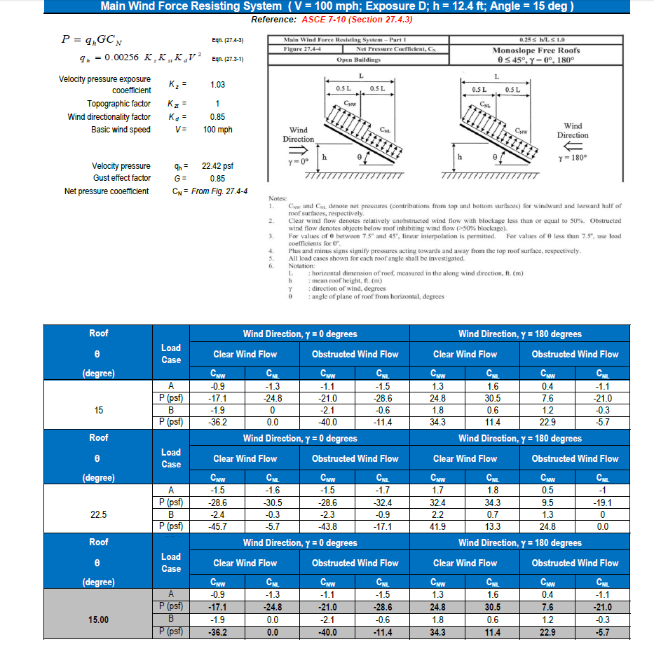

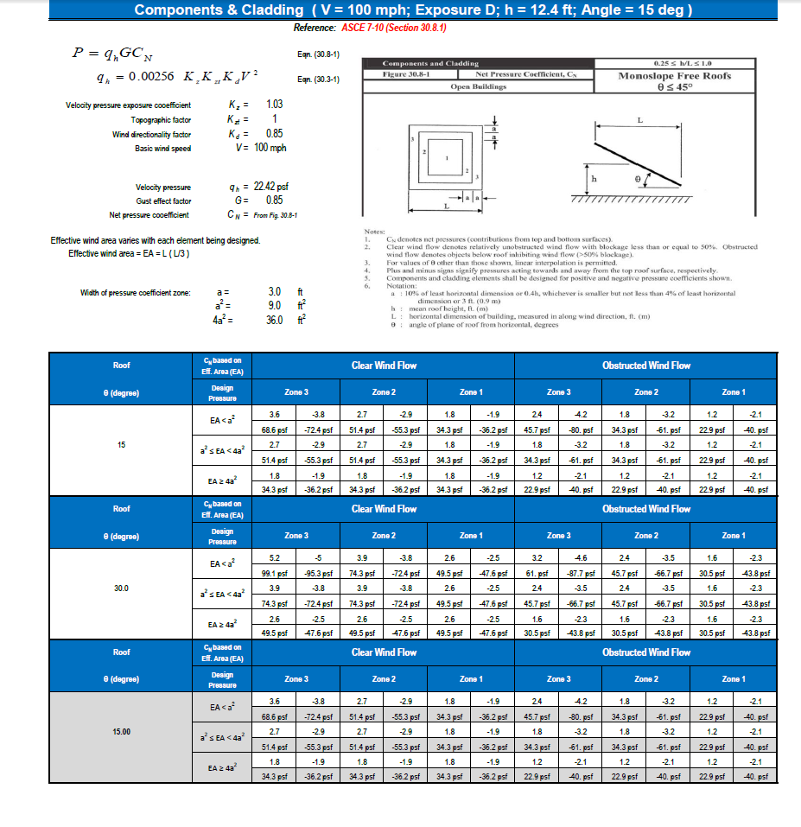

Table1.2-3 below outlines what type of wind pressure was used to analyze the members of the carport structure.

#### Table 1.2-3: Wind Pressure Types Used for Structural Members

|  |  |  |  |  |
| --- | --- | --- | --- | --- |
| **Struct. Member:** | **Deck** | **Purlin** | **Beam** | **Column** |
| Wind Type: | C&C | C&C | MWFRS | MWFRS |

All wind pressures presented in the wind charts shown above were used in GS-USA to carry out the analysis. The load cases used in the analysis are from ASCE 7-10 Section 2.4.1 (And CBC 2013) as per the ASD method. The load cases used are as shown below.

1. D
2. D +Lr or S
3. D + 0.75(Lr or S)
4. D + 0.6W
5. D + 0.75(0.6W) +0.75(Lr or S)
6. 0.6D + 0.6W

# 2.0 Finite Element Model

The carport was modeled using GSUSA Frame 3D. The columns, beams, and purlins shown in Fig. 1.0-1 and Fig. 1.0-2 were modeled as Beam2 elements. A Beam2 element is a space beam element that is modeled using a start node for the beginning point of the beam, an end node for the end point of the beam, and a reference node that must be in the plane of bending of the beam element.2 Typically the reference node is placed so the plane of bending is about an elements strong axis, which is how the beam elements are modeled in this structure. In theory though this reference node, and therefore the plane of bending, can be placed anywhere in the model which would cause the beam element to bend about a plane that is not necessarily its strong axis, which is not ideal for modeling a three-dimensional structure. The deck was modeled as a series of QB4 elements (or 4-noded quadrilateral elements) of differing sizes. The QB4 elements are the plate elements that were differed in size and quantity for four different models in order to obtain a more refined mesh size, and therefore a more accurate model of the structure.

In order to model the structure according to the problem description, each model that was analyzed had the deck, or plate elements, connected to the purlins at specific nodes depending on the desired mesh size. The purlins were then connected to the beams which transferred the loads to the columns. Therefore the nodes corresponding to the plate elements were either only attached to other plates or attached to the purlins. The columns were fixed from displacements and rotations in all axes at their base to ensure the stability of the structure. Fig. 2.0-1 below shows an example of the carport modeled in GSUSA Frame 3D, with the columns, beams, purlins (Beam2 elements), and deck (QB4 Elements) labeled appropriately.

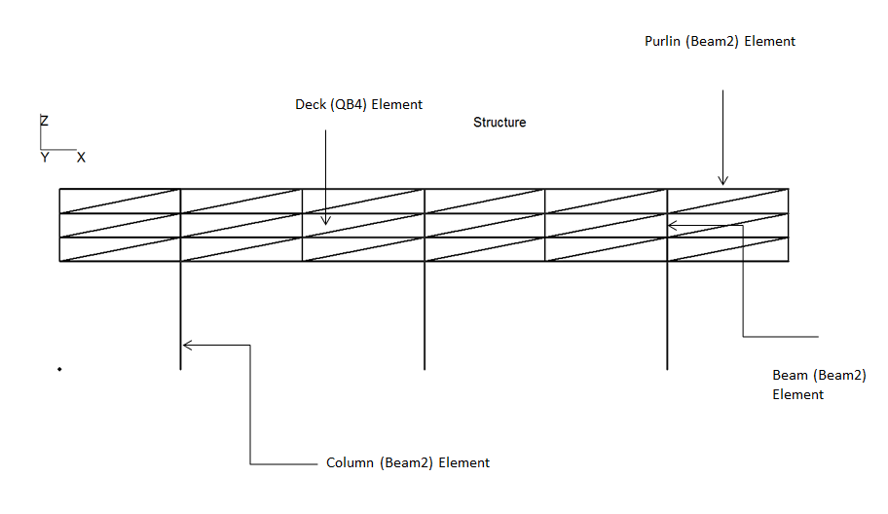

### Fig. 2.0-1: Example Profile View of GSUSA Model

## 2.1 Material Properties

The material properties used in the finite element models that were analyzed are presented in Table 2.1-1 below.

#### Table 2.1-1: Material Properties

|  |  |  |  |  |  |
| --- | --- | --- | --- | --- | --- |
| Material | Young’s Modulus  (psi) | Density (lbm/in3) | Yield Stress  (psi) | Poisson’s Ratio | Tensile  Stress  (psi) |
| A992 HRS (Beams and Columns) | 29*106 | 7.3499*10-4 | 50*103 | 0.3 | 65*103 |
| A446 CFS (Purlins) | 29*106 | 7.3499*10-4 | 55*103 | 0.3 | 75*103 |
| A446 CFS (Decking) | 29*106 | 7.3499*10-4 | 80*103 | 0.3 | 95*103 |

## 2.2 Cross-Sectional Properties

The cross-sectional properties of the four cross-sections used in the finite element analysis of the structure are described in Table 2.2-1 below.

#### Table 2.2-1: Element Cross-Sectional Properties

|  |  |  |  |  |  |  |
| --- | --- | --- | --- | --- | --- | --- |
| Element Type | Cross-Section | Web Height (in) | Web Width (in) | Flange Width (in) | Flange Thickness (in) | Thickness (in) |
| Column | I-section | 8.0 | 0.5 | 5.0 | 0.5 | - |
| Beam | I-section | 8.0 | 0.5 | 5.0 | 0.5 | - |
| Purlin | Channel-section | 8.0 | 0.25 | 3.0 | 0.25 | - |
| Deck | Plate | - | - | - | - | 1 |

# 3.0 Finite Element Results

In order to demonstration convergence of the stresses and displacements the structure was modeled and analyzed four times, using different mesh sizes for the decking. The size of each individual plate element decreases with each model, therefore increasing the amount of plate elements in the model. The cross-sectional properties of the columns, beams and purlins remained constant for each model along with the thickness of the deck. This was to ensure that the only variable affecting the accuracy of the models was the amount and size of plate elements being used to model the structure. Only the live load of 20 psf was used in four models to prove convergence. The governing basic load cases for the MWFRS and CC conditions were analyzed in the final model.

The von Mises stress was used to show the convergence of the finite element analysis on the decking. The first model had a mesh size of 9’x6.667’, and used a total of 18 plate elements. Fig. 3.0-1 below shows von Mises stress distribution of the deck for the first model.

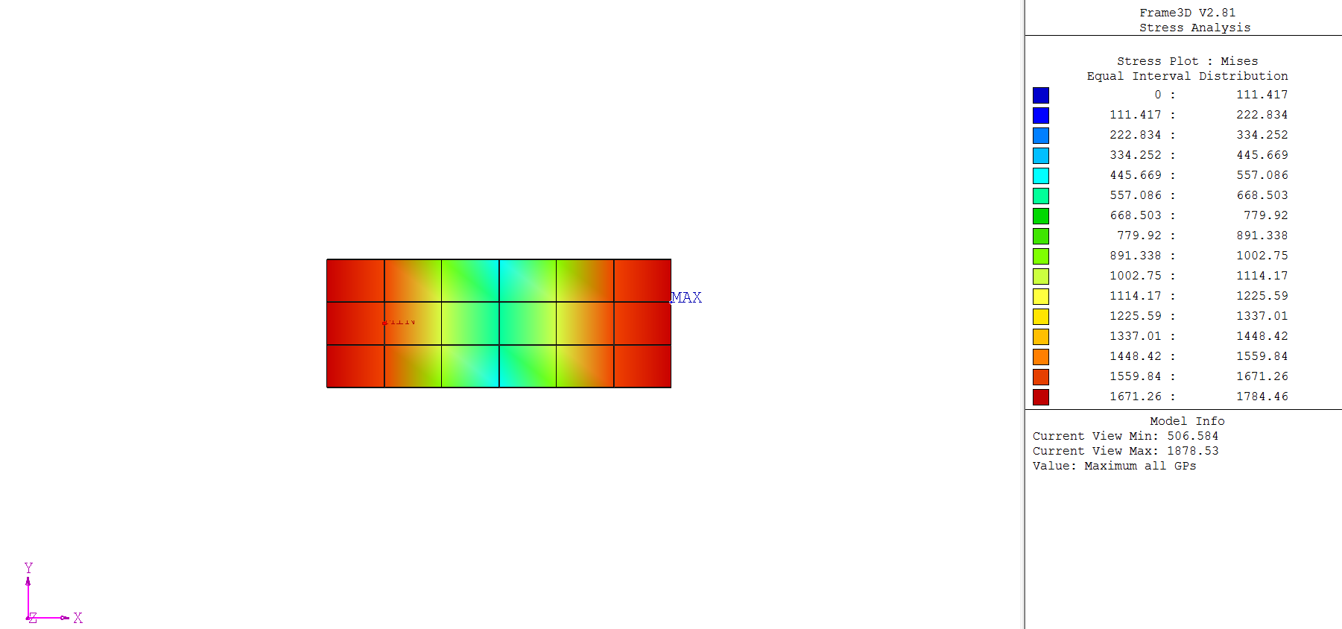

### Fig. 3.0-1: Von Mises Stress Distribution of Model 1

This figure shows that the maximum stress in the model was 1878.53 psi, located at the outer edge of the deck. The maximum displacement found in this analysis was -1.11904 in.

The second model that was analyzed had a mesh size of 4.5’x3.3335’ and a total of 72 plate elements. Fig. 3.0-2 below shows the von Mises stress distribution of this model.

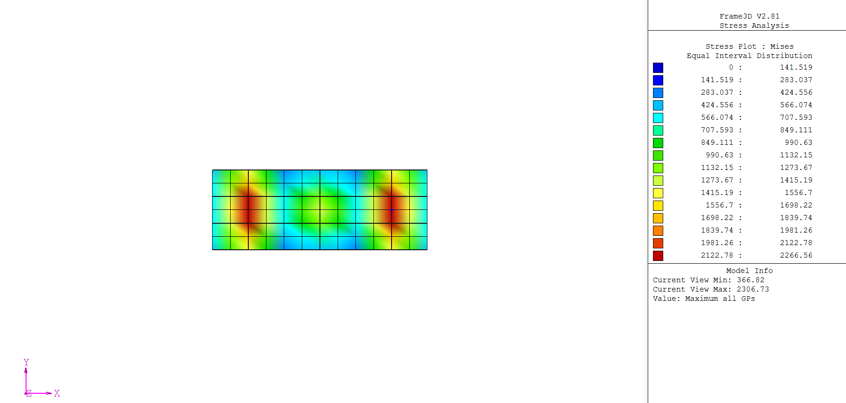

### Fig. 3.0-2: Von Mises Stress Distribution of Model 2

This figure shows that the maximum stress in this model was 2306.73 psi, located near the outer columns. The maximum displacement found in this analysis was -0.910415 in.

The third model that was analyzed had a mesh size of 3’x2.222’ and a total of 162 plate elements. Fig. 3.0-3 below shows the von Mises stress distribution of the final model.

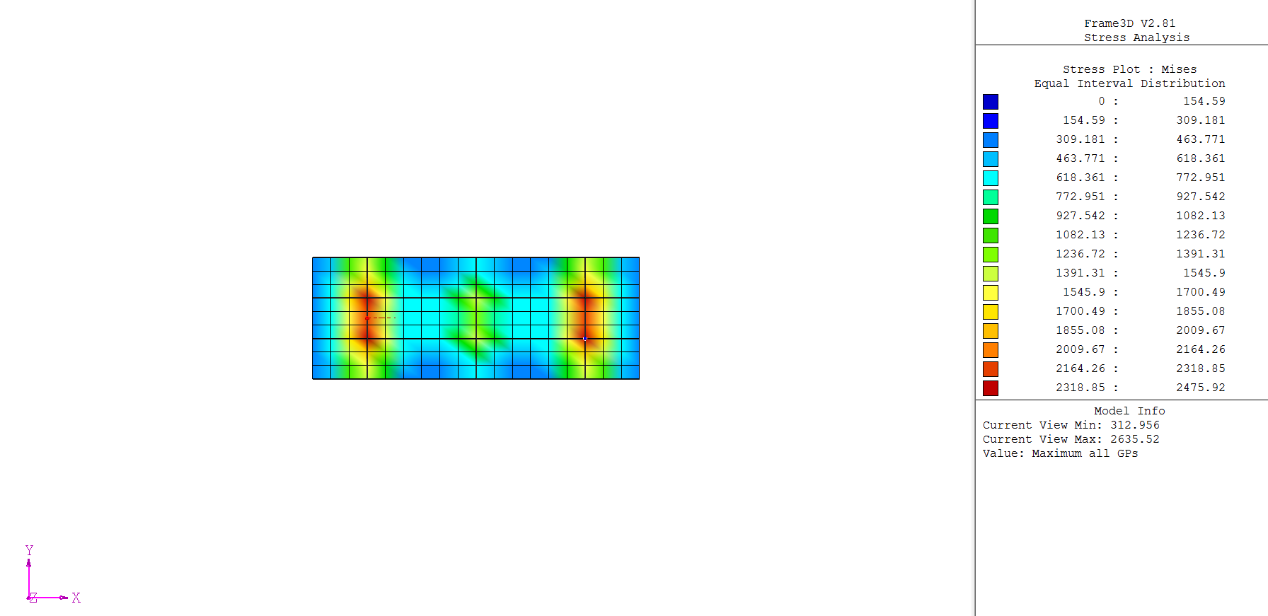

### Fig. 3.0-3: Von Mises Stress Distribution of Model 3

This figure shows that the maximum von Mises stress in this model was 2635.52 psi, located near the outer columns. The maximum displacement found in this analysis was -0.863044 in. Although it was apparent that this model was close to convergence, one more model was analyzed to verify the convergence of the finite element analysis.

The final model that was analyzed had a mesh size of 2.25’x1.667’ and a total of 288 plate elements. Fig. 3.0-4 below shows the von Mises stress distribution of the final model.

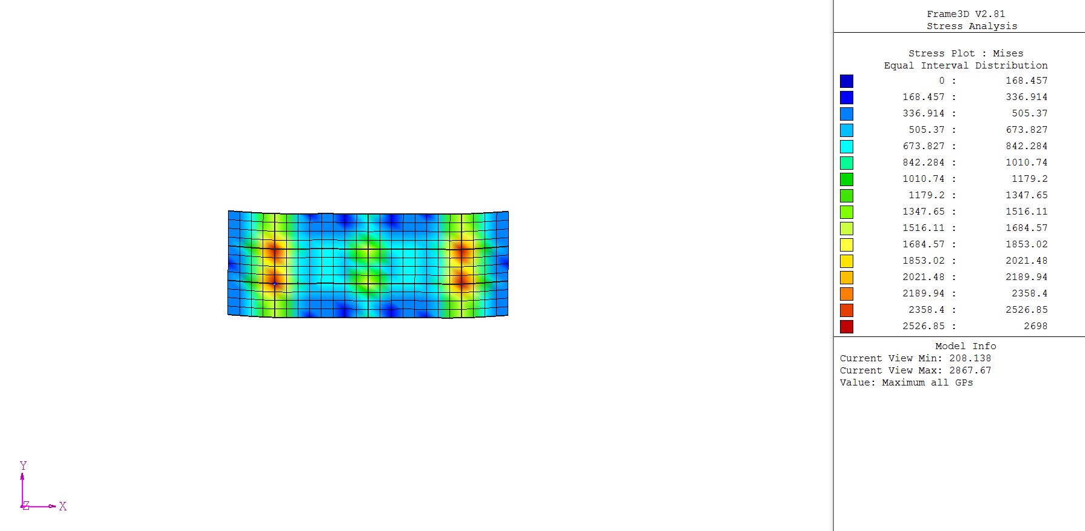

### Fig. 3.0-4: Von Mises Stress Distribution of Model 4

This figure shows that the maximum stress in this model was 2867.67 psi, located near the outer columns, where the beams and purlins connect. The maximum displacement found in this analysis was -0.850099 in. The small difference between the von Mises stress and the maximum displacement between this model and model 3 shows an obvious converging trend.

Table 3.0-1 below displays the results from the finite element analysis of the carport structure.

#### Table 3.0-1: Results from the Finite Element Analysis

|  |  |  |  |  |
| --- | --- | --- | --- | --- |
| **Model** | **Element Type** | **Number of Plate Elements** | **Maximum Displacement (in)** | **Von Mises Stress (psi)** |
| 1 | QB4 | 18 | -1.11904 | 1878.53 |
| 2 | QB4 | 72 | -0.910415 | 2306.73 |
| 3 | QB4 | 162 | -0.863044 | 2635.52 |
| 4 | QB4 | 288 | -0.850099 | 2867.67 |

Fig. 3.0-5 below shows the maximum displacement as a function of the number of plate elements.

### Fig. 3.0-5: Displacement versus # of Plate Elements

Fig. 3.0-6 below shows the von Mises stress versus the number of plate elements.

### Fig. 3.0-6: von Mises Stress versus # of Plate Elements

Both Fig. 3.5 and 3.6 above show that there is convergence with an increasing number of elements used in the finite element analysis.

## 3.1 Analysis of Carport with Basic Load Cases

Using the loading conditions as determined from ASCE 7-10, we can generate the von Mises stress state for the decking and also determine the maximum compressive, tensile and shear stresses in the beam elements. Note that the load cases as described in Section 1.2 will not be used in the analysis, and only basic load cases will be analyzed.

Governing Load case for WL C&C

The governing basic load case for the decking and purlins under wind loading (C&C) was due to obstructed wind flow in the upward direction. The loading shown below illustrates a 40 psf uplift across the entire area of the decking.

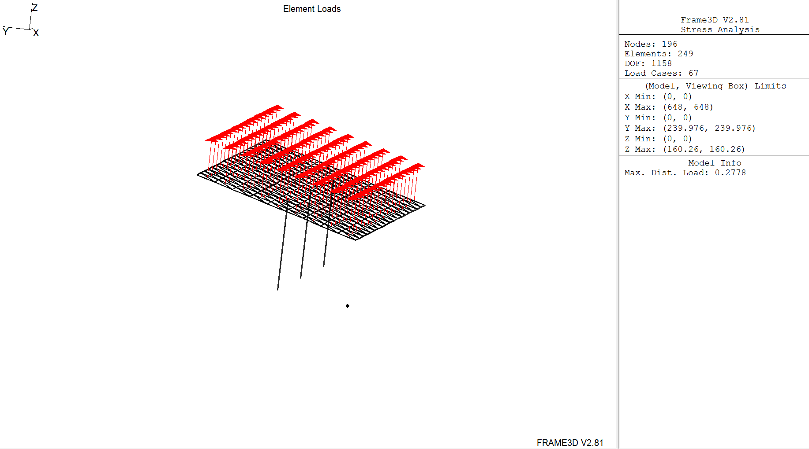

### Figure 3.1-1: Governing Wind Load Case for CC

The following plots display the stresses found in the non MWFRS structural elements. All maximum stresses are tabulated in Table 3.1-1.

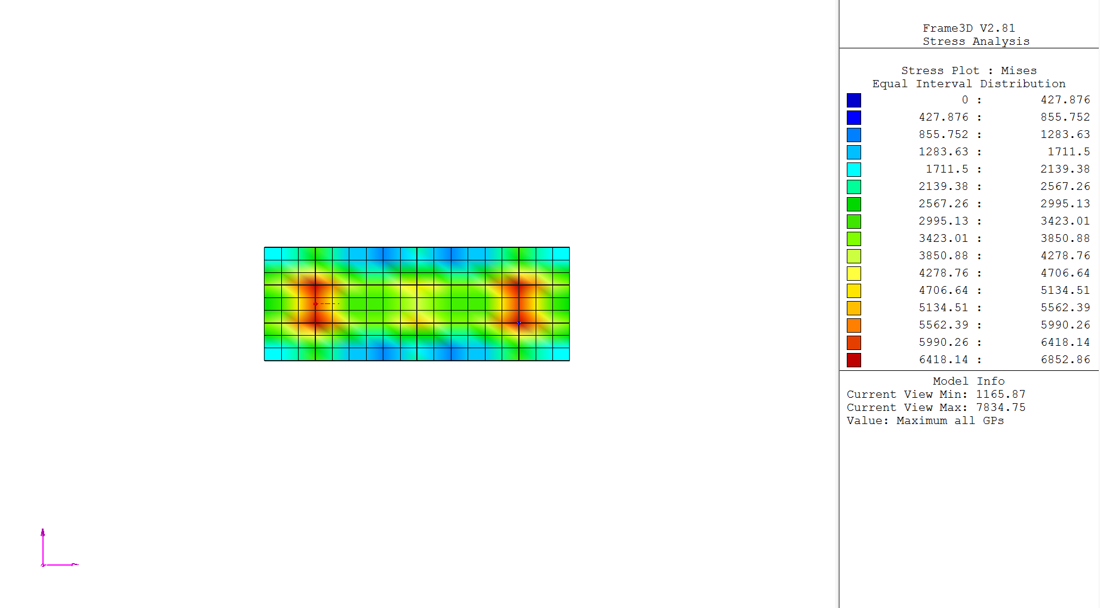

### Figure 3.1-2: Von Mises Stress Distribution for Governing Wind Load Case for CC

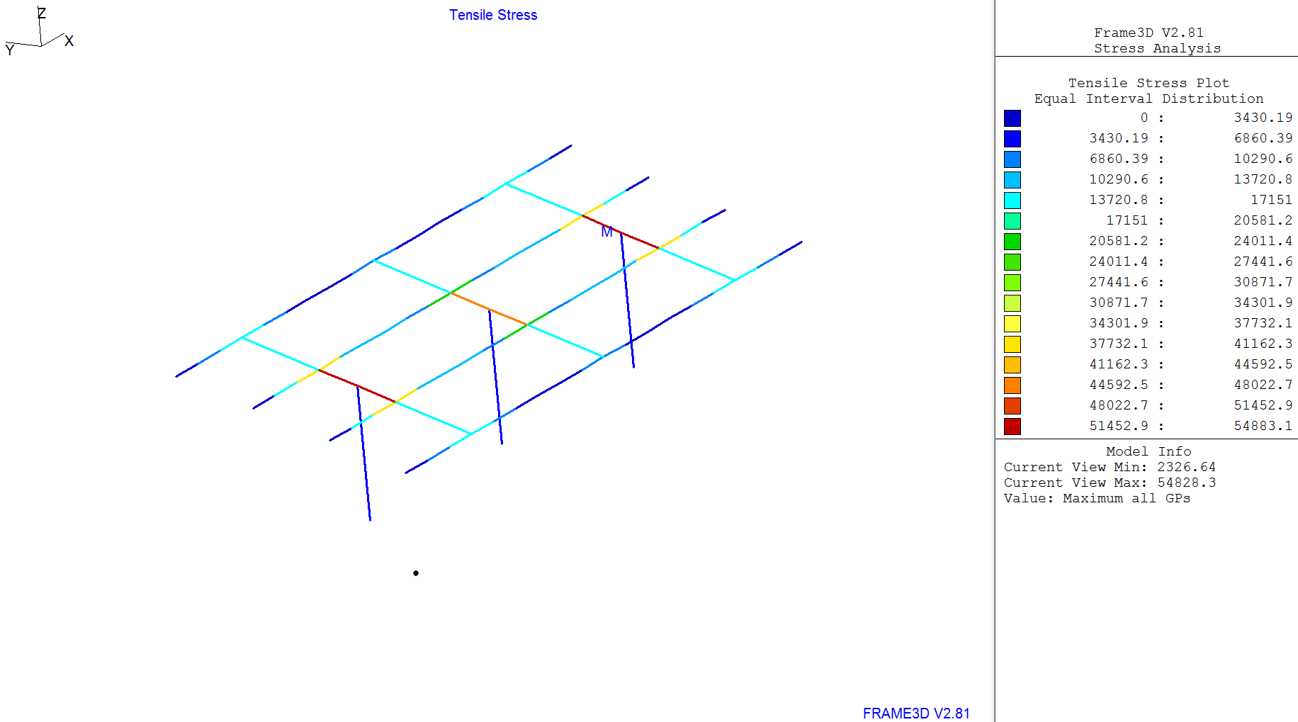

### Figure 3.1-3: Tensile Stress Distribution for Governing Wind Load Case for CC

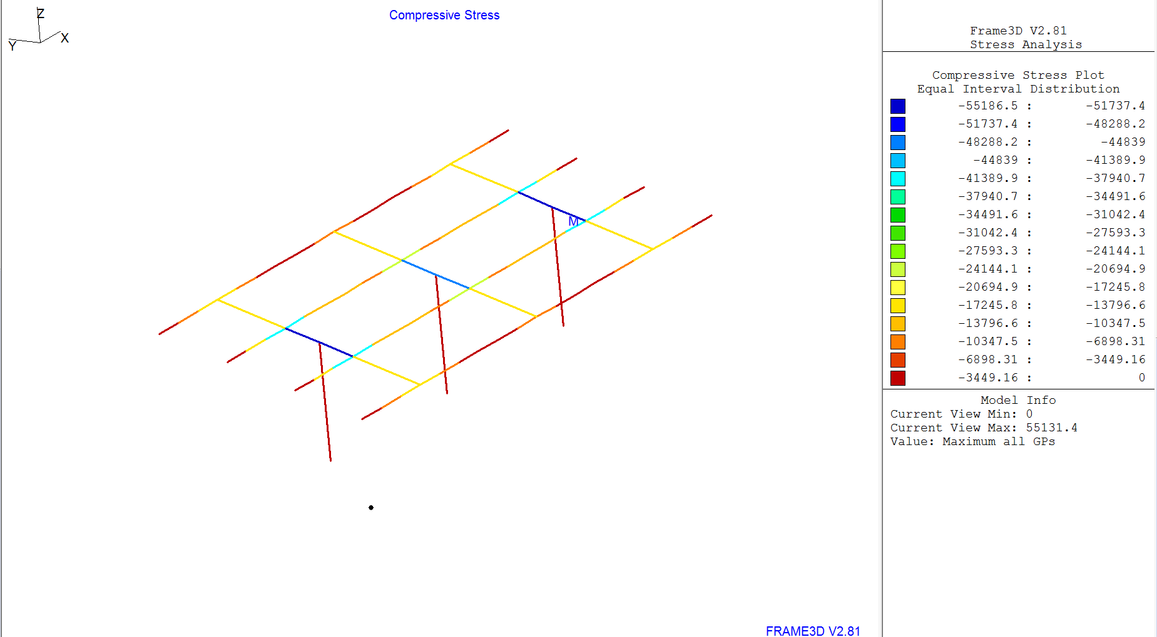

### Figure 3.1-4: Compressive Stress Distribution for Governing Wind Load Case for CC

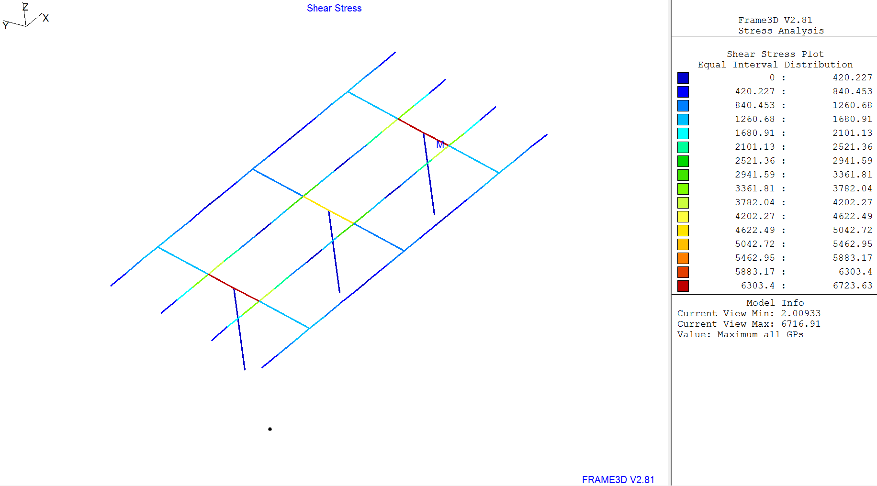

### Figure 3.1-5: Shear Stress Distribution for Governing Wind Load Case for CC

#### Table 3.1-1: Stresses for Gov. C&C Wind Pressure

|  |  |  |  |  |
| --- | --- | --- | --- | --- |
|  | von Mises (psi) | Tensile Stress (psi) | Compressive Stress (psi) | Shear Stress (psi) |
| Decking | 7835.75 | - | - | - |
| Purlins | - | 40652.5 | 40644.1 | 3881.08 |

The maximum von Mises stress for the decking was found near the purlin-beam joint closest to the outer columns, and the maximum tensile, compressive and shear stresses in the purlins were found at the same location.

Governing Load case for WL MWFRS

The governing basic load case for the beams and columns under wind loading (MWFRS) was due to obstructed wind flow with the wind going in the direction underneath the incline. The loading shown below illustrates the wind uplift across the face of the decking. The uplift on the high-side is 40 psf, and the uplift on the lower side is 11.4 psf.

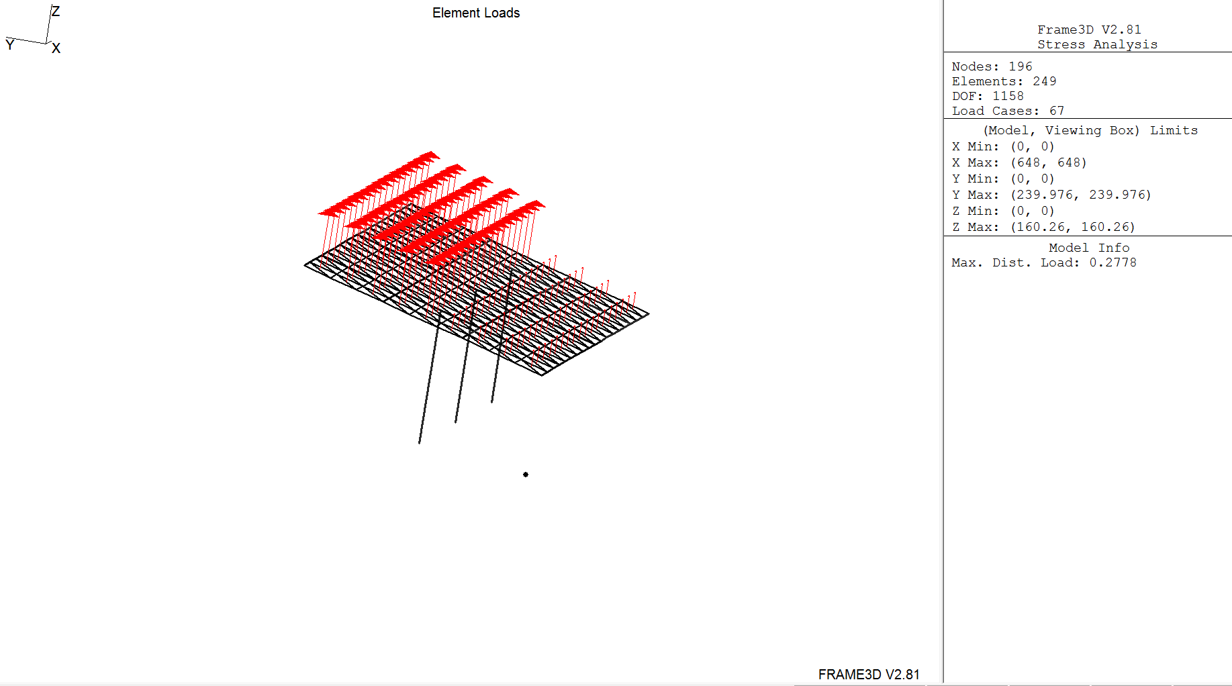

Wind Direction

### Figure 3.1-6: Governing Wind Load Case for MWFRS

The following plots display the stresses found in the MWFRS structural elements. All maximum stresses are tabulated in Table 3.1-2.

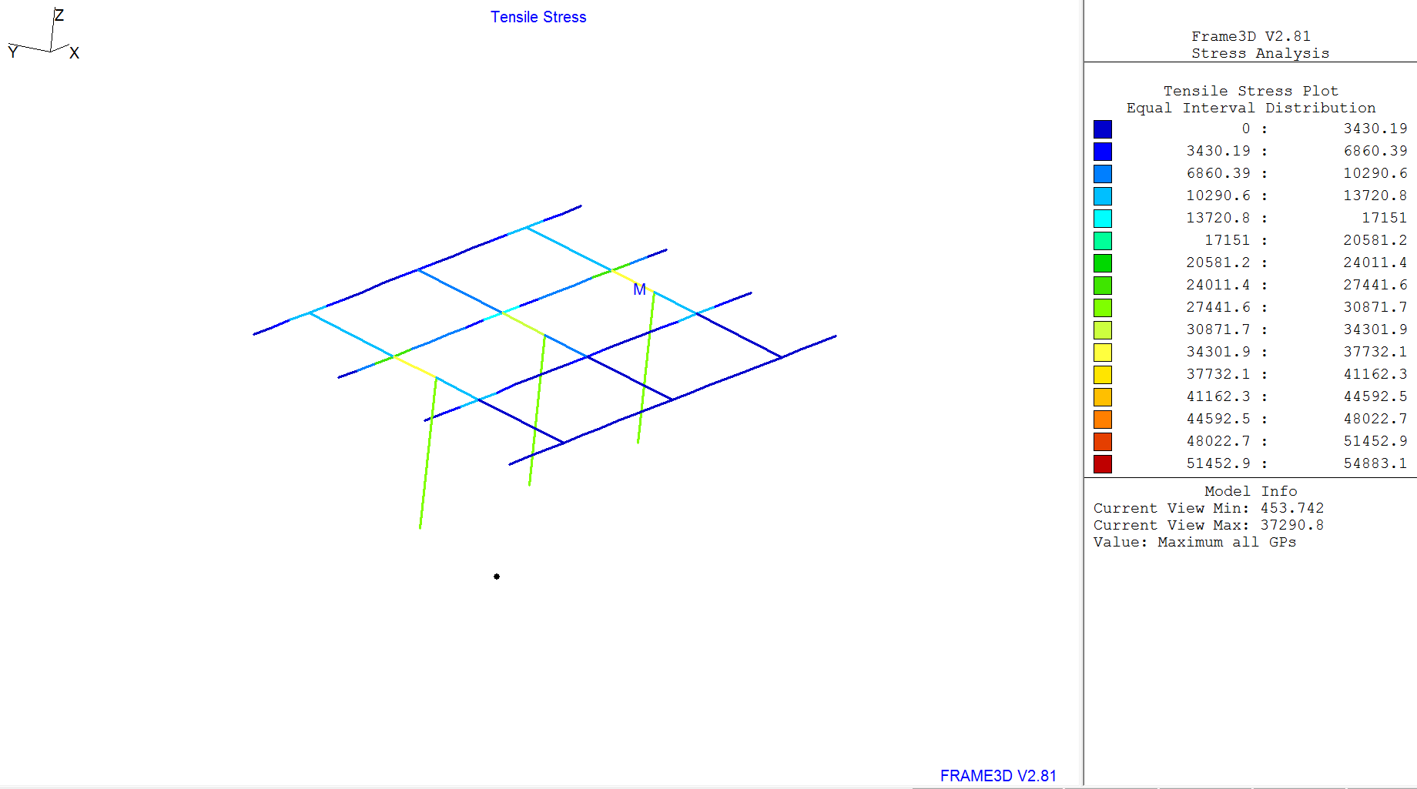

### Figure 3.1-7: Tensile Stress Distribution for Governing Wind Load Case for CC

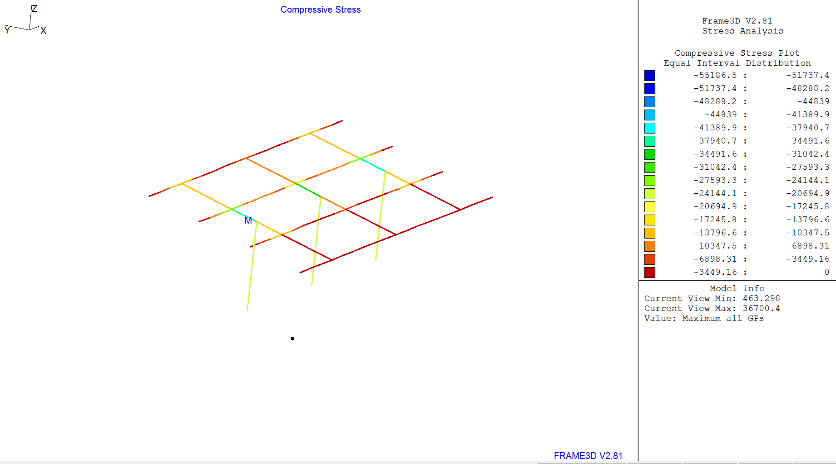

### Figure 3.1-8: Compressive Stress Distribution for Governing Wind Load Case for CC

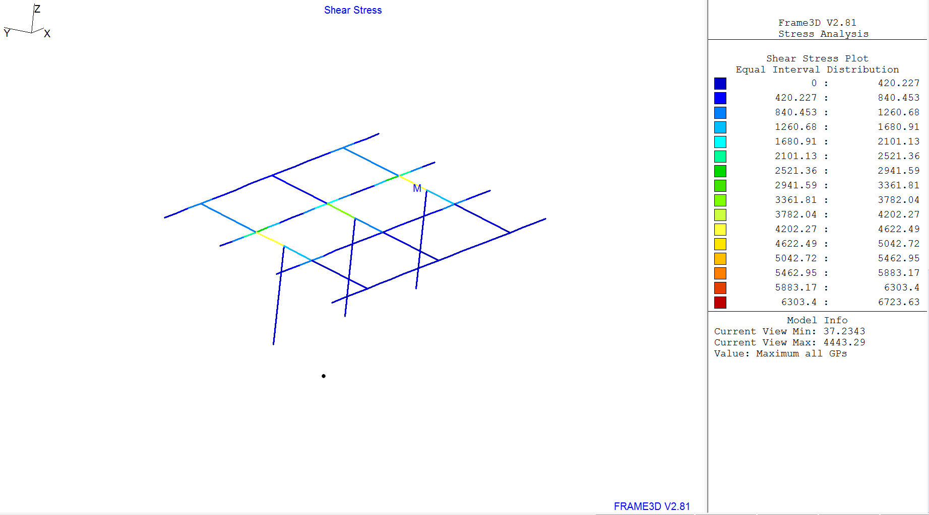

### Figure 3.1-9: Shear Stress Distribution for Governing Wind Load Case for CC

#### Table 3.1-2: Stresses for Gov. MWFRS Wind Pressure

|  |  |  |  |
| --- | --- | --- | --- |
|  | Tensile Stress (psi) | Compressive Stress (psi) | Shear Stress (psi) |
| Columns | 28728.6 | 23933.5 | 100.22 |
| Beams | 37290.8 | 36700.4 | 4443.29 |

The maximum tensile and compressive stresses for the columns were found in the outside columns, and the maximum shear stress was found in the inner column. The maximum stresses for the beams were found in the elements closest to the beam-column joints (tensile, compressive and shear).

Roof Live load

The von Mises stress distribution for the live load case can be seen in Fig. 3.0-4. The loading shown below illustrates the live load of 20 psf acting on the decking of the carport.

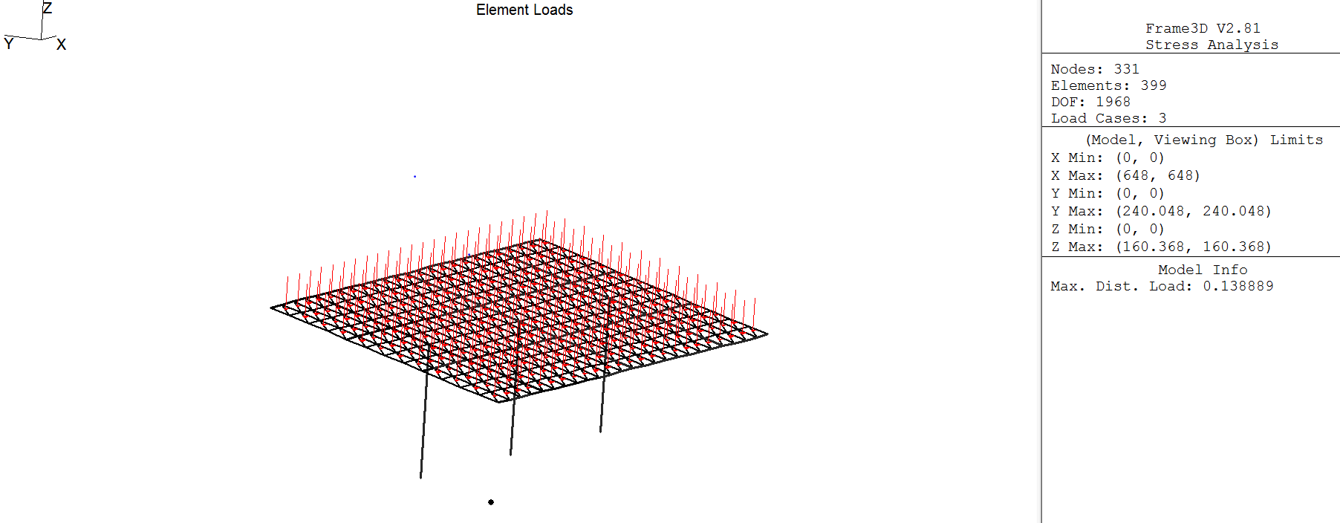

### Fig. 3.1-10: Live Load

The following plots display the stresses found in the columns, beams, and purlins for the live load. All maximum stresses are tabulated in Table 3.1-3.

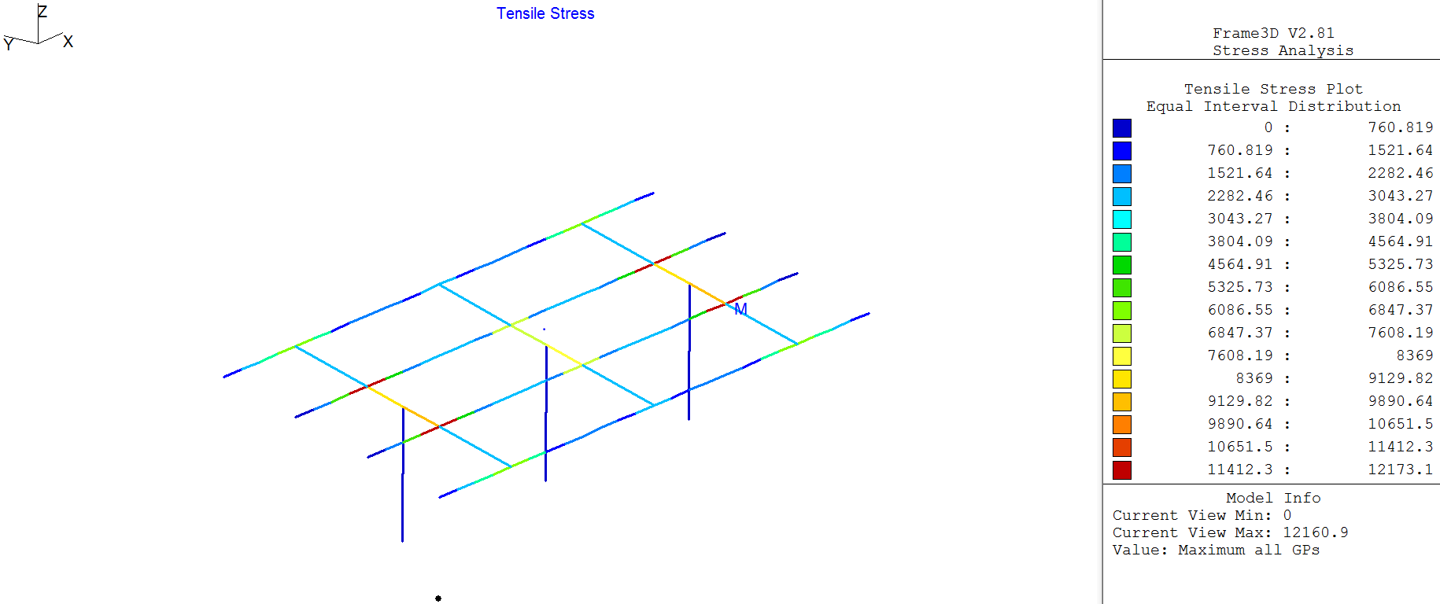

### Figure 3.1-11: Tensile Stress Distribution for Live Load Case

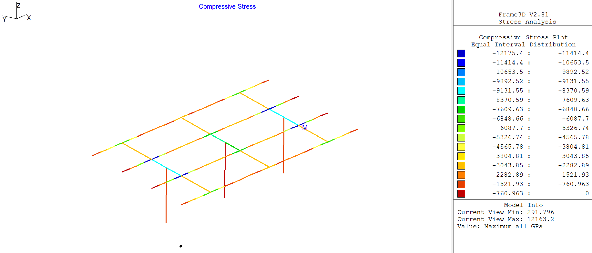

### Figure 3.1-12: Compressive Stress Distribution for Live Load Case

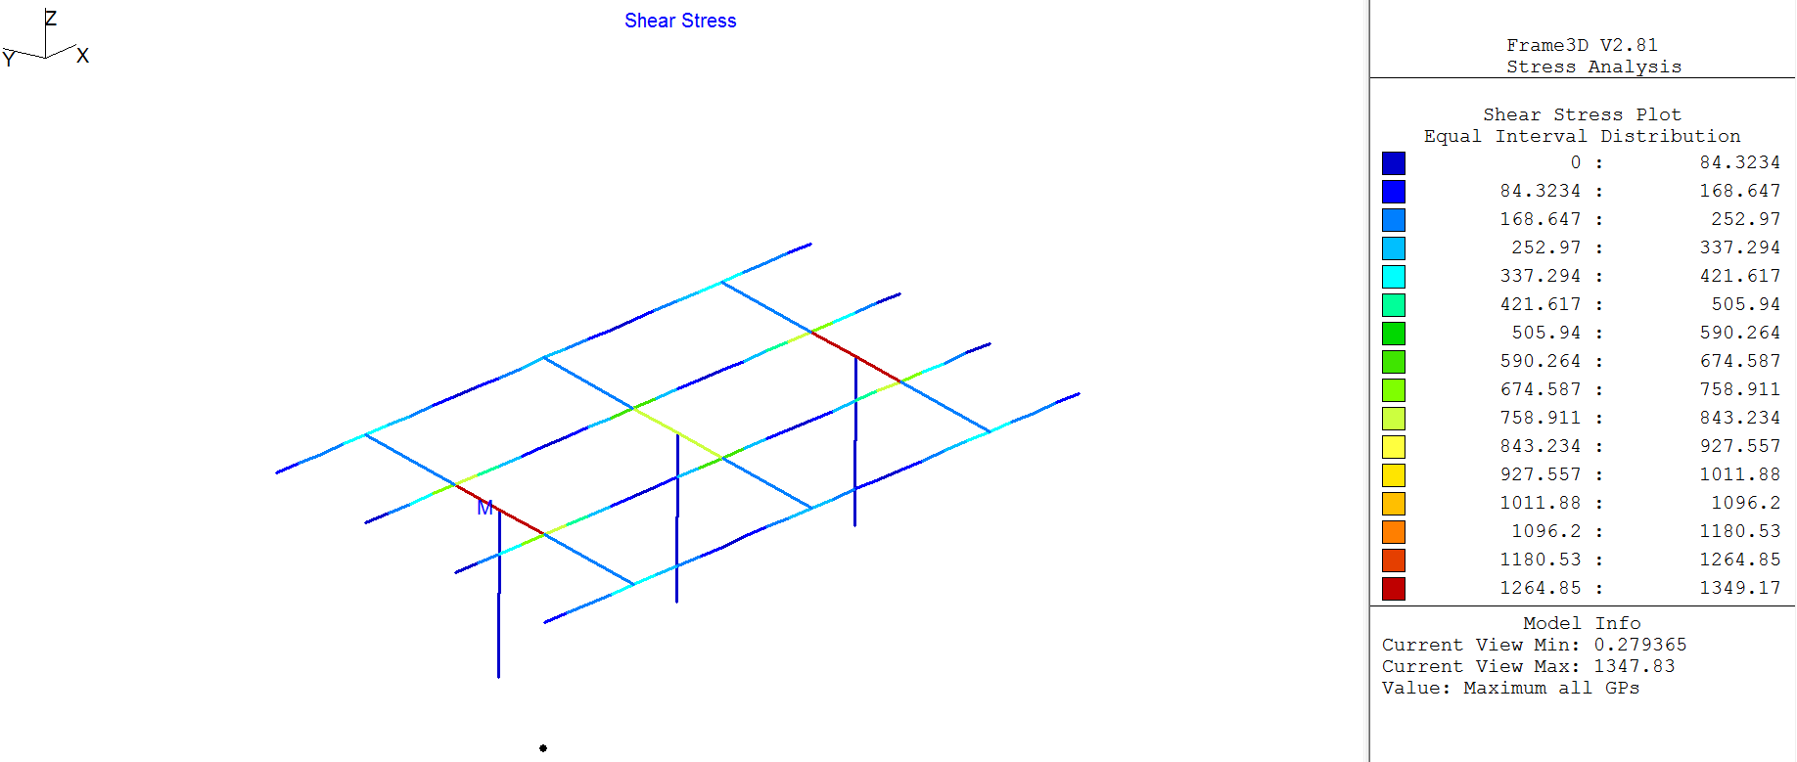

### Figure 3.1-13: Shear Stress Distribution for Live Load Case

#### Table 3.1-3: Stresses for Live Load Case

|  |  |  |  |
| --- | --- | --- | --- |
|  | Tensile Stress (psi) | Compressive Stress (psi) | Shear Stress (psi) |
| Columns | 0.0 | 1143.76 | 9.96 |
| Beams | 9162.76 | 9095.32 | 1347.83 |
| Purlins | 12160.9 | 12163.2 | 829.503 |

Although the difference was minimal, the maximum tensile, compressive, and shear stresses for the columns were found in the outside columns. The maximum stresses for the beams were found in the elements closest to the beam-column joints (tensile, compressive and shear). The maximum stresses for the purlins were found near the purlin-beam joint closest to the outer columns.

Snow Load

The following plots display the stresses found in the columns, beams, and purlins for the snow load of 5 psf. All maximum stresses are tabulated in Table 3.1-4.

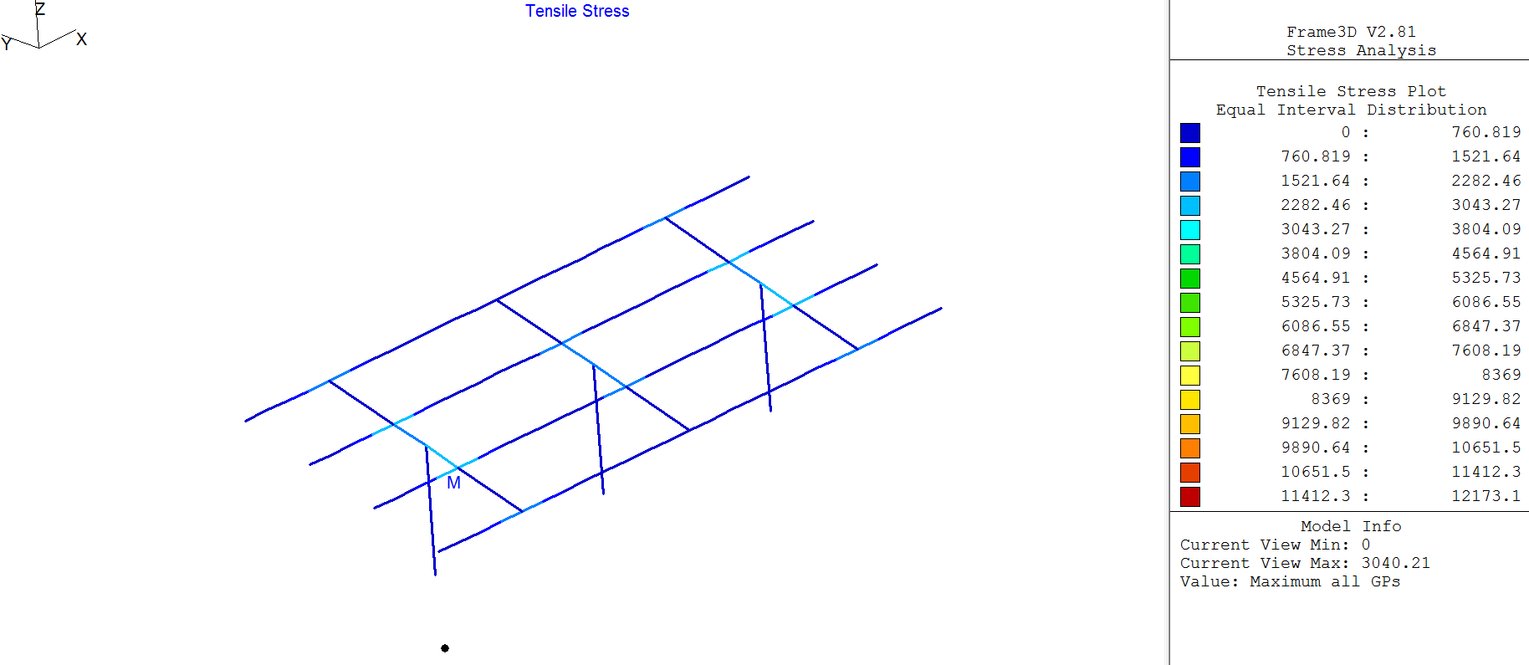

### Figure 3.1-14: Tensile Stress Distribution for Snow Load Case

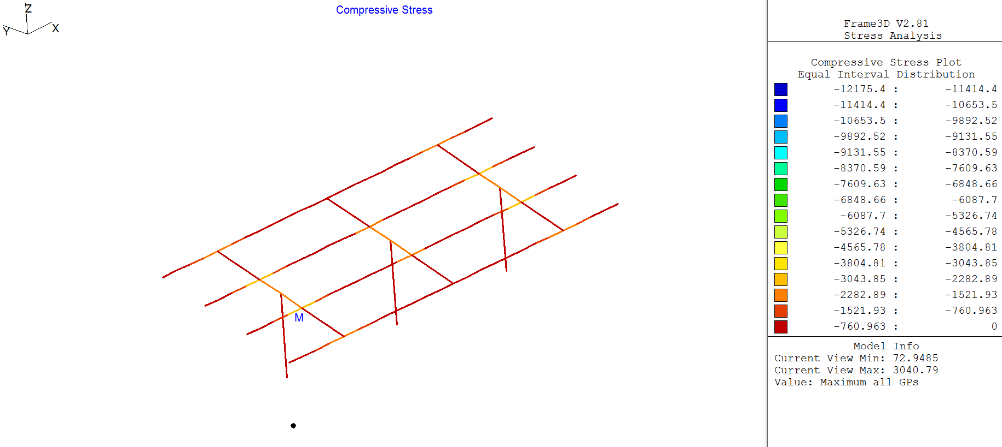

### Figure 3.1-15: Compressive Stress Distribution for Snow Load Case

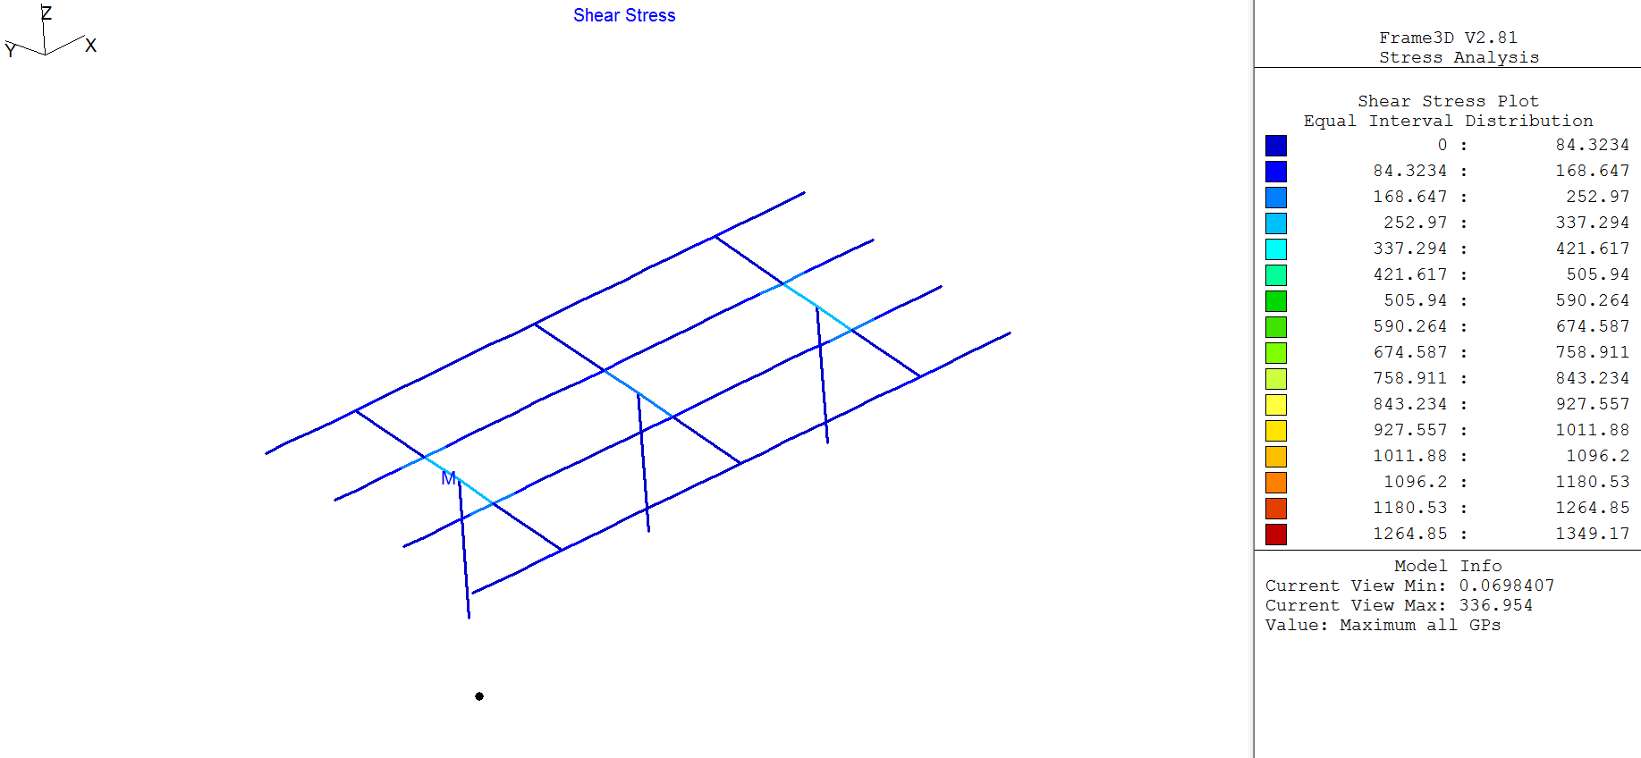

### Figure 3.1-15: Shear Stress Distribution for Snow Load Case

#### Table 3.1-4: Stresses for Live Load Case

|  |  |  |  |
| --- | --- | --- | --- |
|  | Tensile Stress (psi) | Compressive Stress (psi) | Shear Stress (psi) |
| Columns | 0.0 | 285.94 | 2.49 |
| Beams | 1579.44 | 1910.41 | 207.35 |
| Purlins | 3040.21 | 3040.79 | 336.95 |

Similarly to the live loads, the maximum tensile, compressive, and shear stresses for the columns were found in the outside columns. The maximum stresses for the beams were found in the elements closest to the beam-column joints (tensile, compressive and shear). The maximum stresses for the purlins were found near the purlin-beam joint closest to the outer columns.

Knowing the governing wind conditions for the specific structural elements, these wind cases in addition to the dead, roof live and snow load can be used in the load cases as mentioned in Section 1.2. Using the maximum stresses and displacements found from the governing load case, the carport structure can be designed with the most optimal result as per the code.

# 4.0 Conclusions

The following conclusions can be made from the conducted finite element analysis of the carport structure.

* Higher refinement of the mesh produces convergence to the actual solution of a finite element model
* The maximum displacements converge faster than the von Mises stresses.
* While the stresses converged from below (they are underestimated), the displacements converged from above (overestimated). Theoretically the displacements should also converge from below.
* Load cases as per ASCE 7-10 were not used in the analysis as there were some issues with the response of plate elements under derived load cases. Only basic load cases were used in the analysis.

# 5.0 References

1. Rajan, Subramaniam, *FE Modeling Case Studies*. Tempe: n.p., Oct. 2008. PDF.

* Note: This reference was used as a template to the report.

1. Rajan, Subramaniam, *User’s Manual for the GS-USA FRAME3D Computer Program*. Tempe: n.p., Aug. 2000. PDF.
2. *California Building Code*. N.p.: Intl Code Council, 2013, Print.
3. *ASCE (American Society of Civil Engineers) 7-10*. N.p.: Intl Code Council, 2010, Print.